
Stock Productivity
2007-2008:
Summery:
I have been looking in to the Sales of 24-7prayer’s products for the last year (January ‘07’ to January ‘08’), seeing if there are any themes or offers that are working better then others, if there’s anything that can be done to increase the profitability of the shop area of the website.

Overall our best and most constant sales have been on 24-7 clothing has made up 47% of our sales, due to the release of the YOU SEE BONES clothing range in January of 2007. This year the merchandise stand has been to quite a few locations and the clothing has sold well with great feedback, people loving that our new range is so Biblically based and that it has links with the vision, a great evangelistic tool. Unfortunately some of the paper trail on the Stand sales has gone missing, I can tell the amount of stock that’s been sold but not the month! As we sell the most stock at Soul Survivor which is in August I have put all the Stand sales for the year in to August. There are peaks & troughs this is due to selling a lot in February and then only have a few sizes left and so sales dip, when we got more in again in July sales let up. It would be really nice if we had enough money to order larger quantities of Stock so that our sales would even out and we could provide more customer care.

Our C.D sales have decreased over the last year taking in 22% of our orders, I’m going to re-think of how we sell the CD as having made many offers with them, I feel that making CD’s sound like a good deal again could be hard! I’m hoping that the worship CD that Brian and James are working on could do a little something to help the sales of the Rock, Beats & Chill CD.

The our 24-7 prayer sales on books have taken 20% of our sales, we’ve had a gradual incline of sales from march to July due to the release of God on Mute at the end of February. We saw the financial befits in March and April. To continue the good wave of book sales Red Moon Rising leaped up in sales in May to July also. This is partly due to one church ordering 20 so they could envision their youth.

What I have found interesting from doing these charts is seeing how Downloads are a healthy and constant. The free talks we offered after the feast in Seville have boosted our Download sales, This is great as Downloads are reasonably cheap to put tighter and a way of getting the message of Prayer out there. I’m excited to develop this area of the shop and are already working with jonnie in making the site easer to use so that a larger marketing push on the downloads can take place.

I am pleased to see that people are taking the opportunity to order more resources (Newsletters, Pray & He May Change Leaflets, The Vision Post Card), alot of time and effort has been put into raising the standard with what we send to people & prayer rooms so there’s is a better understanding of what 24-7prayer is and what it does.

When I view this chart it shows me that throughout the year there doesn’t seem to be any trends or patterns in peoples buying, we can see that there seems to be a lull in trade in the autumn and that January it dipped as well, this shows that the web shop is visited throughout the year.

This review of the productivity is purely a focus on stock. I have not taken in to account staffing costs or the cost of our on-line processing fees from ‘SEC pay’ & ‘World pay’. Our postage packaging is not taken in to account either as when a customer orders stock they are charge postage and packaging separately.

In 2007 the 24-7 Shop took a total of £6055.76 worth of trade ☺
Our cost price outlay for all this has been £3074.48 This is handy to know that however much we invest in to the shop it is returned nearly 2 fold (1.96). Also if we want to be earning more money from the shop we can make a rough estimate of how much we will have to invest in to it to make the desired profit.

BOOKS:
In the last year our profits in books alone was £1209.05, that’s an increase on 2006.

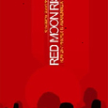
Our best seller was Red Moon Rising making us a profit of £288.29 24% of our Book takings! One of the reasons its higher then the other books is because in July there was one community that brought a bundle of 20 Red Moon Rising that really pushed the sales up. Red Moon Rising also falls in to 3 of our shop offers, Buy 3 get one free, Buy RMR & The manual get the Manual half price & anyone who’s registering a prayer room gets a £1 discount on any book. The offer that has worked the best was offer 2= Buy a RMR & Prayer Manual and get the manual half price. The other offers were only used in a couple of times in June. 64% of People brought the book at full price, this makes me want to advertise the offers more, they are a great opportunity to get the 24-7 Vision out there and with RMR 2 coming out soon we should really push them now while people are still being envisioned by this book.

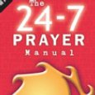
The 24-7Prayer manual has brought us in £257.34, 21% of our total book takings. Last year the manual was the best seller and brought us in the most money, if it weren’t for the one purchase of 20RMR in July then the manual would continue to have been the best seller! Although this book is a few years old now I would still like these sales to increase to double what it’s bringing in at the moment. It s the only book on how to put a prayer room together and that makes it an essential for prayer rooms, I’d like to make a page on the site saying how great the manual is similar to the V&V page.
61% of the sales of the Prayer Manual are at full price. The Offer that has helped the sales of the manual the most is the ‘Buy a Red Moon Rising and get a Prayer Manual for half price’. It’s made up 35% of the income on Prayer manuals. The Manual sales have their peaks and troughs but on average we make £38.25 a month from the book. Sales look like they are picking up towards the end of the year and what’s interesting is that the Manual sales don’t jump as much as other books and although it’s attached to Red Moon Rising via the offer it does seem to have its own sales patterns quite independently of other books.

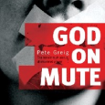
God On Mute has made us a profit of £217.60 that’s only 18% of our book takings, the sales seem to have gone up and down throughout the year, getting better at Christmas, making the total number of books sold in a year 68. It has had good publicity as many people have been waiting for Pete Greig’s newest book, it was on the home page front cover as a pre order and has recently had a story on our E-Newsletter saying how helpful it has been from a customer point of view.

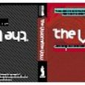
The Vision & vow has made us £201.5. 17% of the total book takings. Which is £487.8 less then in 06 when it came out, This is upsetting as I personally love this book and feel that the content doesn’t age so a push in sales is needed, it already has its own page on the global site written by Pete and packed with reasons why people should buy this book, I think a push through the E-Newsletter is definitely needed for this item and then after we’ve made a bit of money but while the profile is raised and combination deal with The Lord Of The Ring book would be good. The overall yearly sales have their ebbs and flows but all at low levels with no sales in the first couple of months of the year making our total number of books sold in a year 48.

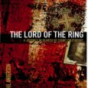
The Lord of The Ring has taken £137.27 that 11% of the Book takings, The first half of the year this book had satisfactory sales, its always going to have a bit of a niche market but sales really have tailed off. Making our total sold for 2007 is 33. This book also had pre- release order advertising. It may be worth thinking about doing some sort offer involving The Lord Of The Ring and the Vision & Vow as they have a common theme, Count ludvig Von Zinzindorff and are both trailing on the sales front.

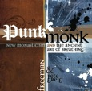
Punk months sales have slowly increased from August bringing in £68.40 profits, it makes up 6% of our sales of books. I hope this rise in orders continues to increase over 2008. As this book is our only one focused on Praying communities I was expecting more sales, I’m sure with the new 24-7 training programs coming in 2008 there will be a natural rise to the profile if this book and more locations for it to appear on the site.

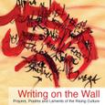
Writing on the Wall is a book of prayers, this is one of our lowest earners bringing us in £17.70, 1% of the total book takings! I really want to push this book as other Christian books of a similar style seem to be sought after. I want to really push the promotion of this either an article or maybe take prayers out of it and have them flash up on the site daily for a featured week? This book is a great resource and it deserves more sales.

Dynamics of Prayer was one on 24-7prayer titles written by Andy Freeman. We had a limited amount that we were just trying to get rid of. Finally that is done and we made £8.50 out of a book worth £1.50 so I suppose that not all bad!

A bundle of the book Walking Backwards was given to us, we have sold 5 making us £15.50, I reduced it to £2.50 in August as we still were getting no orders even though it was only £4. We have now sold out of them. Having sold these books it now leaves our web shop with only 24-7Prayer authors’ books, which I think is a bonus for us. It pushes our brand and put’s a healthy filter on what we sell. I often have people getting in touch hoping that we will sell there product, having a 24-7 authors only rule is very helpful when there product isn’t very good or doesn’t follow some of 24-7’s ethos’s. If a product is good and we do want to indorse it then we also have the flexibility to do that also, by writing an article about it and linking to it from our global site.

Fast Forward was written before the 24-7 Prayer manual was created, it was a brief instruction manual on how to set up a prayer room. I had been trying to sell the last lot of cheaply but they still weren’t selling so I gave the few left over to Andre on the UK prayer team. She gave them to people who were struggling and anxious about doing prayer rooms. It worked in both our favours. These little photo-copied booklets would cost us £1.95 to produce and I was trying to sell them for £1.50 to no avail! In the entire year we sold 7 making us a -£3.15.

Clothing:
In the last year our clothing alone has brought us in £5153.36, that’s an increase of £3275.37 on 2006!
Our actual profit is £3960.45.


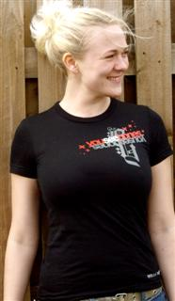
Our best seller has been the YOUSEEBONES clothing range released in January of 2007 it has taken £1941.57 with its Hoodies and £1190.88 on it’s T-Shirts. That is 79% of all the Clothing sold. The YOUSEEBONES clothing range has a fairly steady sales pattern throughout the year, the Clothing really speaks for it’s self on its quality of finish and warmth making it sell well in a Merchandise Stand forum. This year we almost sold out of all our YOU SEE BONES stock at soul survivor. The feed back from customers has been great. Many people liking how warm and how well it sits and many liking the design and wording. Some have mentioned they would like it in other colours, but I think that would be tricky as the design has 3 colours in it. But it would be good to look in to this. The T-shirt is a better seller then the Hoodies throughout the entire year.
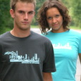

As a trend T-shirts are our best sellers firstly the YOUSEEBONES range and then the Operate in Darkness one making us £336 in the last year 8% of the Clothing sales. I think this is a miracle, we’ve had this range for 3 years now and people are still ordering it, not much but still money is being made. My aim is to run down the stock on this range and the Fire Hands range and create some more designs but that’s all money permitting. The yearly sales for the Operate In Darkness range have been steadily decreasing this is due to the age of the range and the lack of sizes that we have left.

The Fire hands T-shirt has given us a profit of £192. 5% of our yearly take on clothing. The yearly over view of this range has its peaks & troughs but on average we have one sale a month, whether it be T-Shirt or Hoodie.


Continuing down the scale of money earners we have the Operate in Darkness Hoodie making £150. Profit in the last year 4% of the clothing sales and the Fire Hands range making £50 Profit 1% of the total clothing intake. Many girls like the hoodies in these two ranges as they are thinner and hang well, making them look svelte, But lets face it we all love warmth and the thinner hoodies don’t last as long, loosing their shape.


The transmission T-shirts have made us £60. 2% of the clothing sales, it comes above the Fire Hands Hoodie, which is hard as every time we sell one of these T-Shirts we loose money! This is because mission’s teams ordered way to many so we took the rest of the stock off them to try and sell what we can. I have had to reduce them to £6 each but they still aren’t selling well, I have found that people tend to get them from the Merchandise Stand rather then the Web Shop, this is because when were at soul survivor everyone wants a souvenir of there time there and the transmission T-Shirt were the cheapest in the market place.


Our Operate in darkness vest sold really well but its another product that sells better from the Merchandise stand as they do attract a younger clientele and close up you can see the advantages of the 2x2 Ribbed fabric, however this year only a few were sold making us £60. 2% of our clothing sales for the year. I plan on updating the pictures on the web shop as they aren’t great and the design is hard to see. Normally I would expect the sales of this range to increase over the summer months as it’s a summer vest but warm days a few and far between.

The top 3 countries buying our products are the UK at the top, with America second but far fewer sales and then Northern Ireland. In the future before I have any products made I will do more customer research across the nations. I did that with the YOUSEEBONES clothing range and although the sales figures is still pointing out the richer countries I’m confident it is not due to the clothing design. I can’t make that claim however for the other ranges we provide so I’m looking forward to changing that around.

C.D’s:
This year the CD sales have brought us in £1347.69 making it 16% of the shops sales.

Our 24-7prayer CD’s are sold in number of ways it’s very hard to have an exact figure on how a C.D sells. This is because when a customer has ordered on the web shop we can’t see whether they have brought a single CD or part of the 3’s the magic number offer. However when a Stand is done stock is counted in and out of the cupboard so we know how many sales are made in that product line by the difference in the figures when there counted back in to the cupboard. As of yet we don’t have a system where we write receipts so when someone wants to buy a CD from the stand we can sell them 1 Chill C.D or a the 3’s the magic number offer where they are buying a Chill C.D, a Beats C.D and a Rock C.D. We take the right money for their purchase and put it in the cash tin. I have tried to keep on top of counting the bundles that are sold but all it takes is one busy day or one person with to many customers and one bundle sale could slip through the net making all the other days of vigilance worthless!
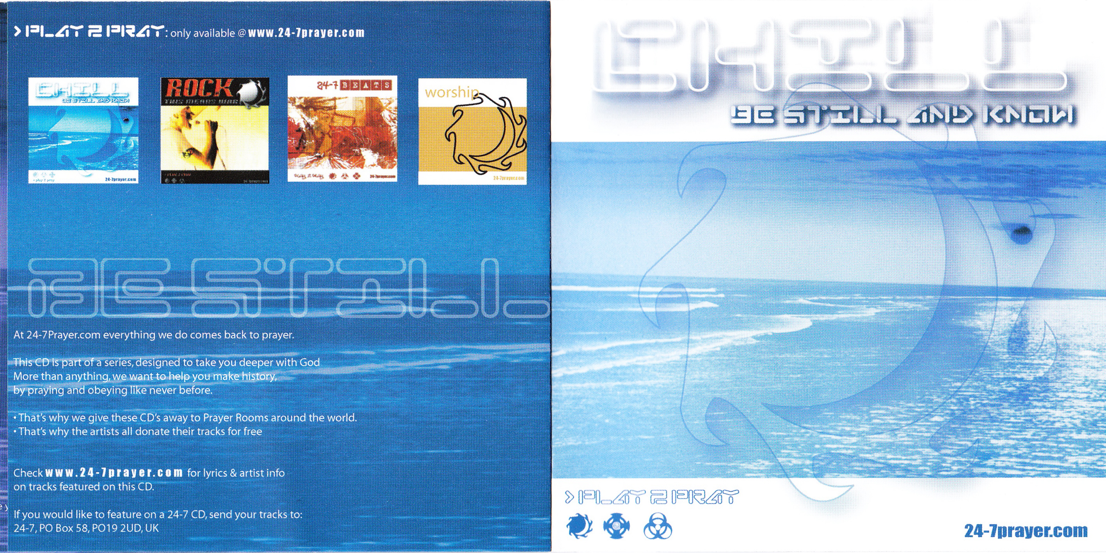
Our best selling making 45% of the CD’s sales is the Chill CD Bringing us in a profit of £698.88 in the last year, £197.12 13% of that is when someone chose the 3’s the Magic number deal. Since its re-release in 2006 the chill CD continues to be the most popular one selling at leased 3 a month if not more. There doesn’t seem to be any patterns coming over the year’s sales so it is hard to see how 2008 will fare!
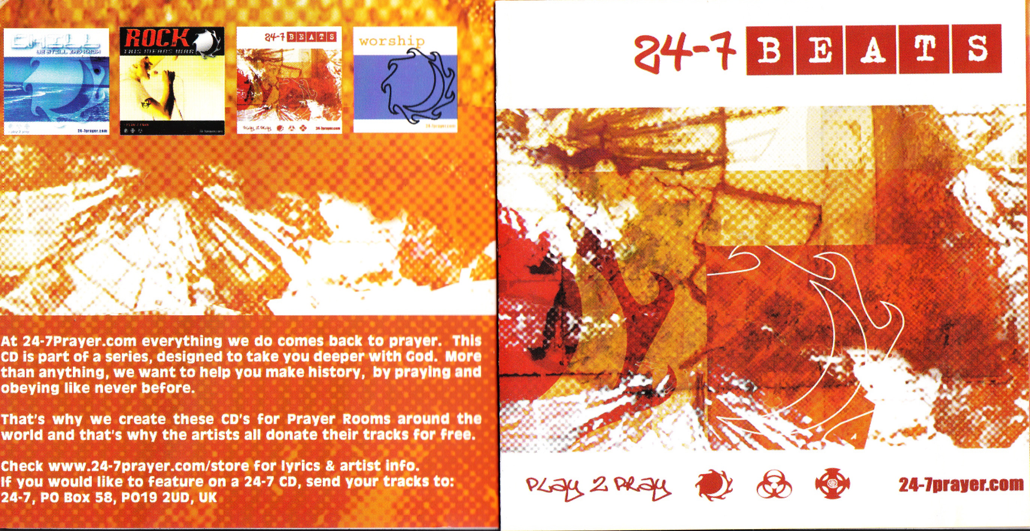
Next would be the Beats CD taking 27% percents of the CD Sales bringing us in £421.12 that is quite a drop from the chill CD especially as £295.68 (19%) came from magic number deals! Most months there’s a sale or two and although there is no visible pattern to that sales, all CD’s stick to one another when one goes up or down so to do the other Chill, Rock or beats CD, this is because of the magic number offer.
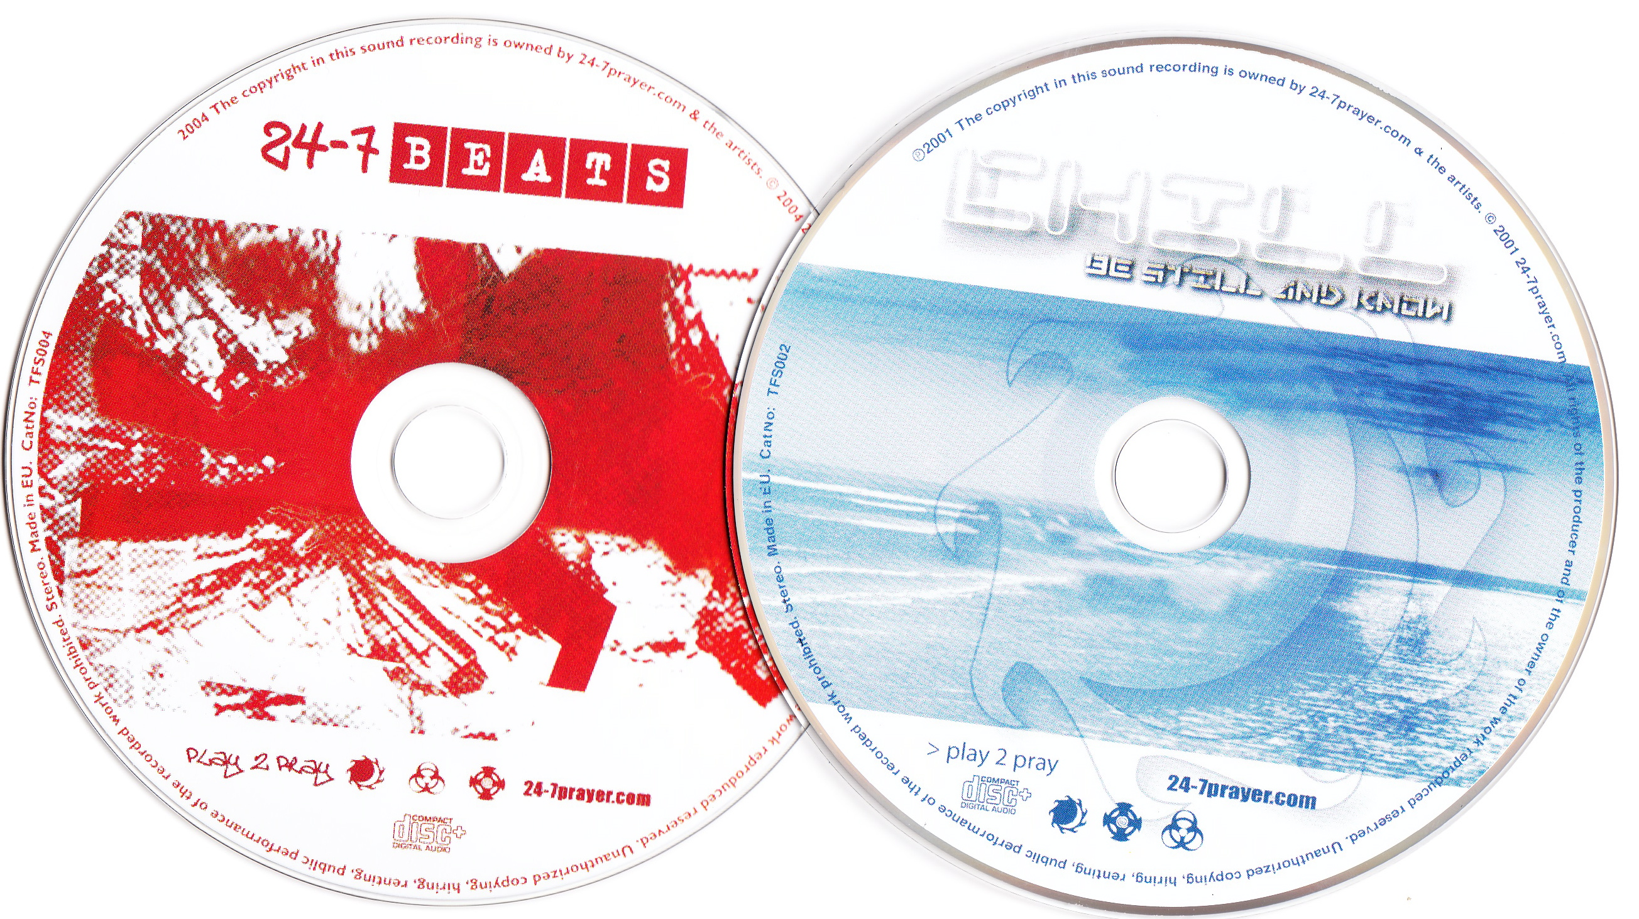
Third would be the Magic offer deal, you can’t treat this as an individual product because it made up of 3 products the Rock, Beats & Chill CD. We took £748.48 in the year with this offer which is higher then the Chill CD but to get a realistic view of how it compares to the single products I divided it by 3 making £249.50 which is lower then the Beats takings & higher then the Rock takings. The yearly sales do have a slowly rising peak during May to July but then as slowly as it rose it drops off as well, ending the year with decreasing sales. I’m hoping that the release of the worship CD in 2008 will lift the sales of this bundle deal as it will be the completion of a set and bring new attention to the CD’s we already have available.

The Lowest 24-7 made CD is the Rock CD making £232.96 (17%) of the CD takings, This CD has been around for many years now and hardly anyone selects it without the offer attached! £188.16 of the total Rock CD taking are from the Magic number offer. We have 100’s left in our stock cupboard so may be I should think of another way to get rid of these CD’s? A Christmas offers where if you buy any thing in the shop you get this CD free??? I’ll have to get my thinking cap on!

Liquid sessions and devout artists were given to us by a 24-7Prayer in house DJ. Liquid Sessions has brought us in £105 (7%) and Devout Artists has made £38 (2%) The profitability shows these products as a high, because there is no cost price just pure profit. That’s a nice gift ☺

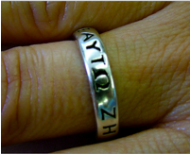
O.M.S. RIng:
The OMS Ring has brought us in £342 over the year 4% of our shop takings. Sales have dropped considerably I think this is because we are not selling as many Vision & Vow books as we used to and that was the way of introducing the Ring to people. Also we’ve been running the stock levels down, The Suppliers we used lost our template and expected us to pay the price of having more made which I think is not professional and rude. No matter where we go we’ll have to pay all the set up costs again, talking to Phil Anderson about the situation and the amount of sales we’ve been making on the Ring, we decided that having more rings made was not cost effective for 24-7prayer. The OMS Site mentions the remaining sizes available, showing the sizes we have and showing clear “How to make an OMS Ring” instructions. It also notes the importance of ethical trading in sourcing a ring.

Our best selling sizes in order:
W= £90 profit 26% of ring sales // S= £72 profit 21% of ring sales // K,N and R= £54 profit 16% of ring sales // U= £18 profit 5% of ring sales.

The sales over the year are very consistent, on average we sell an OMS ring once a month but every now and again that’s raised up to its maximum sales of 4 Rings in July. I have checked the link sales for the Vision & vow book to the ring sales to see if the book affects the rings profit, its not as similar as I thought it would be, there are a couple of months were the sales are the same but that’s not the usual.

Resources:
This year the Resources have brought us in £110. Making it 16% of the shops sales.
The Countries using our resources constantly are the UK with some large bundles of sales going to Northern Ireland.

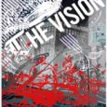
The Vision & Vow Post card is based on the Vision Poem using a similar design style, it also has a short text explaining how 24-7 begun and casting a little vision on Prayer. We aim this resource at Younger people who don’t want to read a lot and would pick up the post card to stick on their wall. The Vision Post card is our most profitable resource making £100 and taking 91% of the income that the resource area brings in. Throughout the year the post card has its highs & lows, This year the highs have been over the months May & June and the lows come directly after in July & August, with these sudden jumps of sales it is impossible to predict sales over the coming year, other then we sell a bundle of 50 post cards every month.

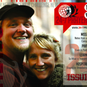
Our next earner in the resource area are the newsletters, meant to be released every quarter. The difficulty is keeping that momentum up, But people do want them, as soon as they were released in October 07 we were having orders of at least 4 bundles of 20 a month, Over the 3 months of 07 that the Newsletters were sold in they brought us in £10. These Newsletters aren’t made to make money but to help spread the story telling virus of prayer globally and people love them. I look forward to the next edition as the newsletters look professional and heavily carry our branding style and are really useful to people joining the movement from any angle and are aimed at the young adult market.

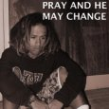
Pray & he May Change is a free resource, this is because more then any other resource we’ve made this one is aimed at asking for support financially and prayerfully. It is aimed at an older generation and briefly touches on all the areas of 24-7Prayer tying them together in a neat and understandable way. We have now run out of these booklets, I think we should have something else made in a similar style as we now have a hole and older more affluent people may find it harder to connect.

downloads:
This year Downloads have brought us in £114.01 of our Shop Takings 1%.

Below are the downloads in order of sales, Obviously the free ones have gone well and that gives hope for the others. The way of finding these talks on our global shop is inadequate and will be changing in 08 with the creation of the new 24-7 website. I’m hoping that giving an extra field like Genre (and others) will help people to order the type of talk they are looking for, more easily.

The genre that is the most popular is Vision, making 29 sales and 25% of our downloads. I attribute this to the free downloads that we gave away after the feast at the end of Nov and continue to do so. The next Download genre to do well was Discipleship (the only style of talk we didn’t give away free!) 26 downloads making 22% of the download sales. Then Mission, although its been downloaded 24 times with 21% of the sales that is due to the free one that was given away in December, throughout the year there had not been much downloading for that genre. Prayer is next on the list with 20 downloads making 17% of the download sales, having at leased one download most months and again there was not a free download that was on prayer so it has done well. The last but not least is Justice making 17 download sales and 15%. Although there was not a free download about Justice its sales have only been taken over Nov & Dec so the more people who have been visiting the Download area of the shop have wanted to buy downloads that are about justice issues.

Genre: | Down load name: | Number Ordered: | Profit: | % of Sales:
Vision | 1. John - We are a People of Destiny by Pete Greig | Free = 23 | £3. | 20%
Mission | 2. John 15 - We are a People of Mobility by Kelly Greene | Free = 17 | £2. | 15%
Justice | 4. John 15 - We are a People of Community by Andy Freeman | Free = 14 | £2. | 12%
Discipleship | Where Angels Fear to Tread by Pete Greig | 11 | £22. | 9%
Prayer | Pray for an Hour! by Andy Freeman | 8 | £16. | 7%
Prayer | Creativity in Prayer by Paul Weston | 5 | £10. | 4%
Discipleship | Spiritual Warfare ñ Lisa Borden | 4 | £3. | 3%
Discipleship | 'Faith' by Arnold Muwonge | 4 | £6. | 3%
Prayer | Teach us to pray - New Monasticism By Andy Freeman | 3 | £6. | 3%
Discipleship | Maintaining Your Spiritual Life ñ Lisa Borden | 3 | £3. | 3%
Vision | Can a Nation be Saved? by Arnold Muwonge | 3 | £6. | 3%
Mission | Christ and Culture -Mark Sampson | 2 | £4. | 2%
Justice | Justice - Re-discovering the face of Jesus by Joyce Heron | 2 | 2p | 2%
Prayer | Teach us to pray - Building Personal Prayer by Lyndall Bywater | 2 | £4. | 2%
Vision | ILG Conclusion - Where do we go from here by Pete Greig | 2 | £4. | 2%
Mission | 'Into the Mystery' by Joe Steinke | 2 | £4. | 2%
Mission | Gospel to the nations-Brian Heasley | 2 | £4. | 2%
Mission | Gospel To The Nation by Brian Heasley | 1 | £0 | 1%
Discipleship | Food for thought (1)-Trent Sheppard | 1 | £2. | 1%
Discipleship | Food for thought (2) -Trent Sheppard | 1 | £2. | 1%
Discipleship | Food for thought (3)- Trent Sheppard | 1 | £2. | 1%
Prayer | Is God speaking to me?- Tre Sheppard | 1 | £2. | 1%
Justice | Social Holiness In The Face Of HIV/AIDS - Juli Catto | 1 | £2. | 1%
Prayer | Meet the Godparents - London City Boiler Room- John Wesley by Jude Smith | 1 | £2. | 1%
Discipleship | Leadership Panel Part 1 ñ Ian Nicholson & Joe & Angie Steinke | 1 | 5p | 1%
Discipleship | Leadership Panel Part 2 ñ Ian Nicholson, Markus Lagel & Kelly Greene | 1 | 5p | 1%
Vision | Church Planting: Something out of nothing -Tommie Naumann | 1 | £2. | 1%

Dog tags:
This year Dog Tags have brought us in £49.70 of our Shop Takings 1%.

The Dog tag that has sold the best is our “6060247365” this is based on the concept and bible verse, that we pray at all times in all ways. We have sold 20 of these which is 28% of all the dog tag sales. The profit of this is only £14 this is because there’s not much mark up, the cost price for a dog tag is £3.80 and we sell them for £4.50 meaning we make 70p per Dog Tag! Not massive, I’ve looked in to other company who are cheaper but the quality of Dog tag is awful, you can bend them like cheap tat!

The next best seller is the Bible Verse, Act Justly Love Mercy, and Walk Humbly with your God. This has sold 16 making it 23% of the Dog Tags total takings, making a profit of £11.30. Then coming in with 13 sales which is 18% of the total Dog Tag Sales and making us £9.10 is another bible verse “Never leave you, Never forsake you”. After those we have our Dog Tag to match our clothing line YOU SEE BONES / I SEE AN ARMY making 9 sales and making us a profit of £6.30 13% of our sales. The last two in the list are another two bible verses “I can do all things / through Christ who sets me free” 7 sales making £4.90 10% and “if God is with us/ no one can defeat us” making 6 sales bringing us in £4.20 and making 7% of our takings.

Incomplete:
This is were for one reason or another and order didn’t go through correctly so I’ve made a fake product with the amount of money they Owe us as the price. This has happened only once in 2007 and the amount the customer underpaid by was £10. But don’t worry I got it ☺

Below is the 24-7 Prayer stock in Productivity order:

Product | Cost Price | Profit
YOUSEEBONES - Hoodies | £ 402.88 | £ 1941.57
YOUSEEBONES – T-Shirt | £ 271.77 | £ 1190.88
3’s the Magic Number | £ 91.52 | £ 748.48
Chill CD | £ 56.16 | £ 698.88
Beats CD | £ 14.56 | £ 421.12
Operate in darkness –T-Shirt | £ 170.64 | £ 336.
Red Moon Rising | £ 292.19 | £ 288.29
Prayer Manual | £ 387.99 | £ 257.34
Rock CD | £ 5.20 | £ 232.96
God on Mute | £ 273.03 | £ 217.60
Vision & Vow | £ 109.20 | £ 201.60
Fire Hands – T-Shirt | £ 101.12 | £ 192.50
Operate in Darkness - Hoodie | £ 89.90 | £ 150.
The Lord of the ring | £ 92.40 | £ 138.27
Liquid Sessions | £ 0. | £ 105.
Vision Post Card | £ 0. | £ 100.
OMS Ring – W | £ 60. | £ 90.
OMS Ring – S | £ 48. | £ 72.
Punk Monk | £ 49.68 | £ 68.40
Transmission – T-Shirt | £ 100. | £ 60.20
Operate in Darkness Vest | £ 26. | £ 60.
OMS Ring – K,N,R | £ 36. | £ 54.
Devout Artists | £ 0. | £ 38.
Download-Where Angels Fear to Tread by Pete Greig | £ 0. | £ 22.
OMS Ring – U | £ 12. | £ 18.
Writing on the Wall | £ 9.80 | £ 17.70
Download-Pray for an Hour! by Andy Freeman | £ 0. | £ 16.
Walking Backwards | £ 0. | £ 15.50
Dog Tag [6060247365] | £ 68. | £ 14.
Dog Tag [Act Justly Love Mercy, and Walk Humbly with your God] | £ 0. | £ 11.30
The Newsletter | £ 0. | £ 10.
Incomplete Orders | £ 0. | £ 10.
Download-Creativity in Prayer by Paul Weston | £ 0. | £ 10.
Dog Tag [Never leave you, Never forsake you] | £ 41.80 | £ 9.10
Dynamics of Prayer | £ 28.50 | £ 8.50
Dog Tag [YOU SEE BONES / I SEE AN ARMY] | £ 34.20 | £ 6.30
Download-'Faith' by Arnold Muwonge | £ 0. | £ 6.
Download-Can a Nation be Saved? by Arnold Muwonge | £ 0. | £ 6.
Download- Teach us to pray - New Monasticism By Andy Freeman | £ 0. | £ 6.
Dog Tag [I can do all things / through Christ who sets me free] | £ 26.60 | £ 4.90
Download- Christ and Culture -Mark Sampson | £ 0. | £ 4.
Download- Teach us to pray - Building Personal Prayer by Lyndall Bywater | £ 0. | £ 4.
Download-ILG Conclusion - Where do we go from here by Pete Greig | £ 0. | £ 4.
Download-'Into the Mystery' by Joe Steinke | £ 0. | £ 4.
Download-Gospel to the nations-Brian Heasley | £ 0. | £ 4.
Download- Spiritual Warfare ñ Lisa Borden | £ 0. | £ 3.
Download-Maintaining Your Spiritual Life ñ Lisa Borden | £ 0. | £ 3.
Download-1. John - We are a People of Destiny by Pete Greig | £ 0. | £ 3.
Download-2. John 15 - We are a People of Mobility by Kelly Greene | £ 0. | £ 2.
Download-4. John 15 - We are a People of Community by Andy Freeman | £ 0. | £ 2.
Download-Food for thought (1)-Trent Sheppard | £ 0. | £ 2.
Download- Food for thought (2) -Trent Sheppard | £ 0. | £ 2.
Download- Food for thought (3)- Trent Sheppard | £ 0. | £ 2.
Download-Is God speaking to me?- Tre Sheppard | £ 0. | £ 2.
Download- Social Holiness In The Face Of HIV/AIDS - Juli | £ 0. | £ 2.
Download-Meet the Godparents - London City Boiler Room- John Wesley by Jude Smith | £ 0. | £ 2.
Download- Church Planting: Something out of nothing -Tommie Naumann | £ 0. | £ 2.
Download-Leadership Panel Part 1 ñ Ian Nicholson & Joe & Angie Steinke | £ 0. | 5p
Download-Leadership Panel Part 2 ñ Ian Nicholson, Markus Lagel & Kelly Greene | £ 0. | 5p
Download-Justice - Re-discovering the face of Jesus by Joyce Heron | £ 0. | 2p
Pray & He May Change | £ 0. | £ 0.
Download- Gospel To The Nation by Brian Heasley | £ 0. | £ 0.



